Lab-9
Question 9:
• Prepare screen list

Screen-1: Login form
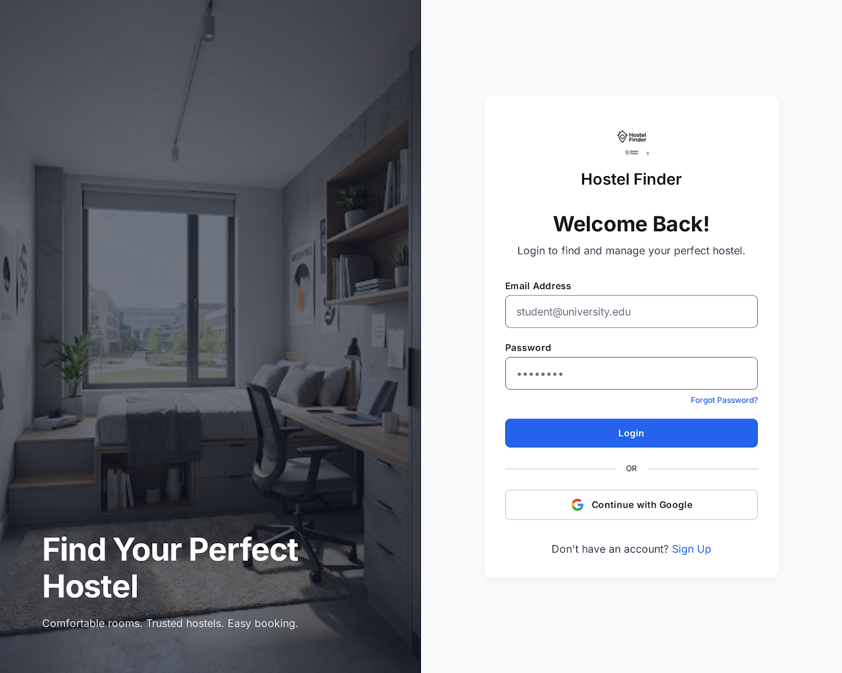
Figure 3.1-1 Screen-1: Patient information Form
Sr. | Screen Element | Input Type | O/M | 1/N | Description
1 | Email ID | Textbox | M | N | Accepts the user's email Id for login.
2 | Password | Textbox | M | 1 | Display Password
3 | Log in | Button | M | 1 | Press the login
4 | Google | Button | M | 1 | Allows the user to log in using a Google account.
5 | Sign Up | Button | M | 1 | Redirects new users to the account registration screen.

Screen-2: Hostel Search
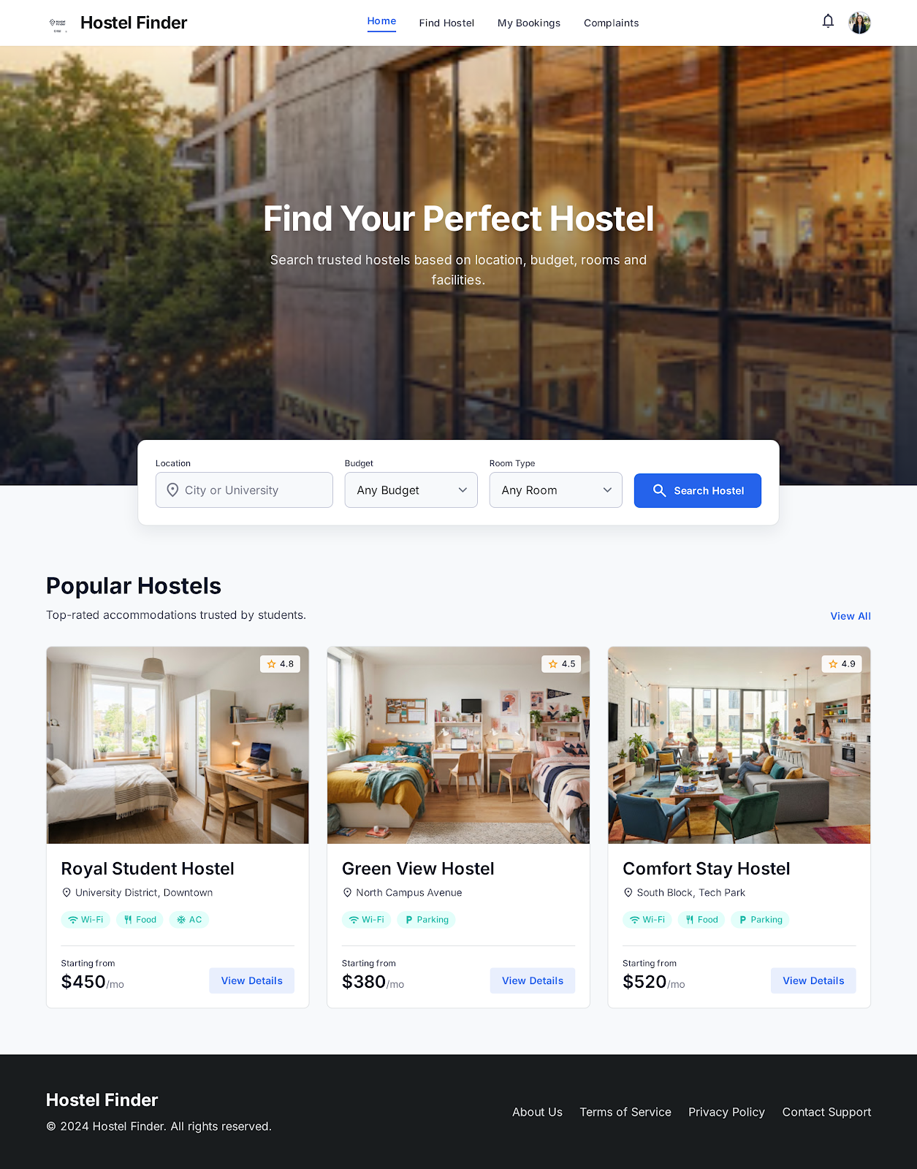
Sr. | Screen Element | Input Type | O/M | 1/N | Description
1 | Profile | - | M | 1 | Opens the user's profile information.
2 | Search Description | Textbox | M | 1 | Displaysinformation about searching hostels by different criteria.
3 | Location | Button | M | 1 | Accepts the city or university for hostel searching.
4 | Budget | Drop down | M | 1 | Allows the user to select a preferred budget range.
5 | Room Type | Drop down | M | 1 | Allows the user to select the required room type.
6 | Search Hostel | Button | M | 1 | Searches for hostels according to the selected criteria.
7 | Hostel Image | - | M | N | Searching Hostel Image

Screen-2: Hostel Details
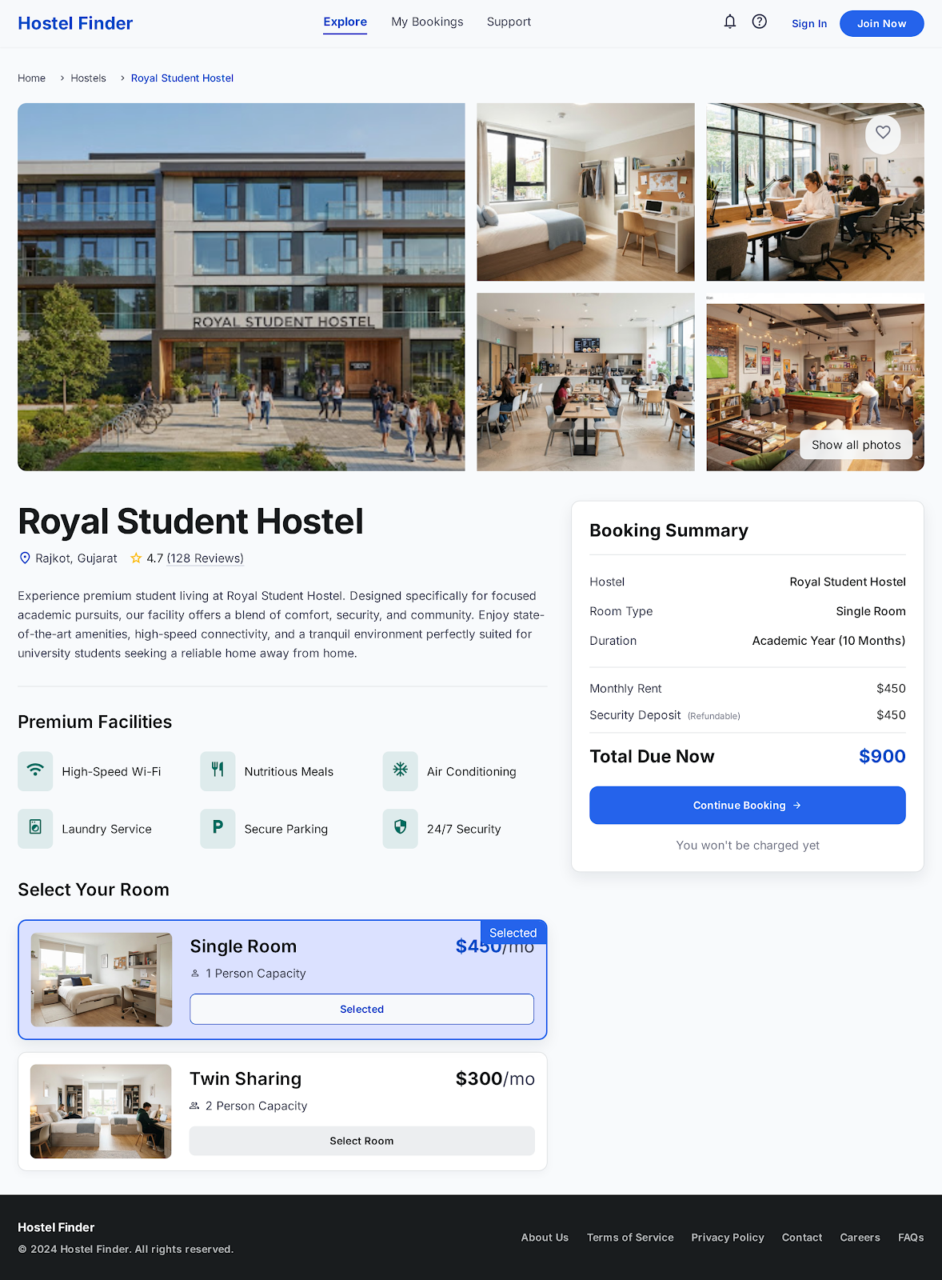
Figure 3.2-1 Screen-2: Doctor detail form
Sr. | Screen Element | Input Type | O/M | 1/N | Description
1 | Navigation bar | - | M | N | Switch Other page
2 | Image | - | M | N | Images of Hostel
3 | Hostel Rating | Textbox | O | N | Displays the hostel rating and review count.
4 | Premium Facilities Box | Textbox | M | N | Displays the facilities available at the hostel.
5 | Select Single Room or Twin Sharing | Radio | M | N | Allows the user to select a Room
6 | Booking Summary | - | M | 1 | Displays the summary of the selected booking.
7 | Footer | - | M | 1 | Details about Hostel Contact

1.4 Screen-4: Complete Booking & Payment
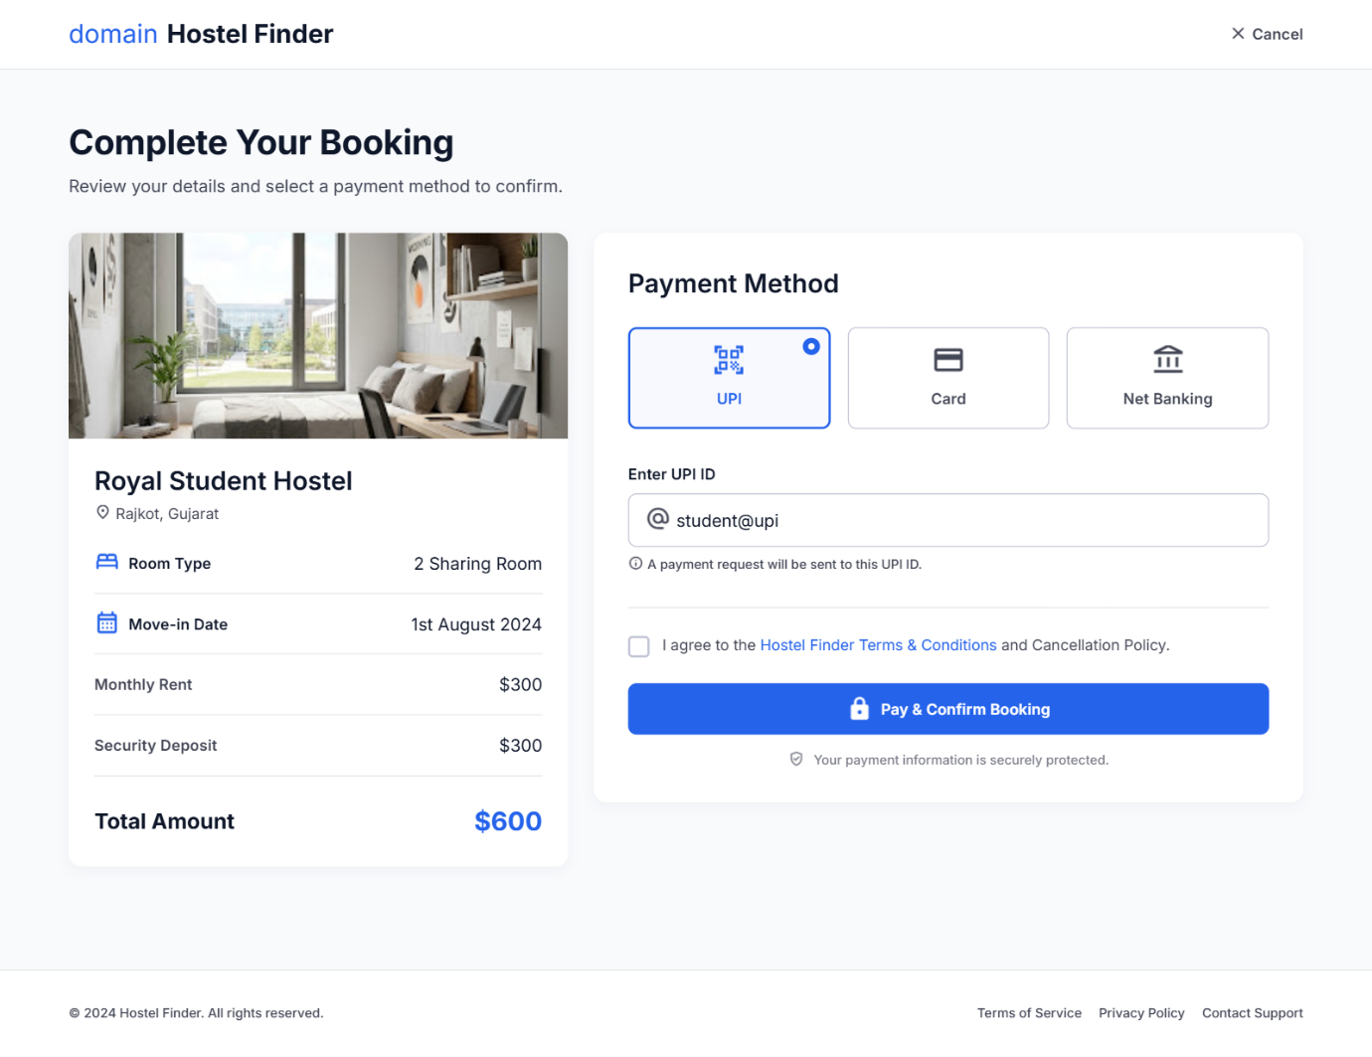

Figure 3.3-1 Screen-3: Appointment booking form

Sr. | Screen Element | Input Type | O/M | 1/N | Description
1 | Cancel | Button | M | 1 | Allows the user to cancel the booking process.
2 | Booking Description | - | M | 1 | Description about your hostel name hostel location and other details
3 | Hostel Image | - | M | 1 | Your Chose hostel image
4 | Payment Method | Radio | M | N | Select Payment Method UPI, Card and Net Banking
5 | UPI ID | Textbox | M | 1 | Accepts the user's UPI ID for making the payment.
6 | Pay & Confirm Booking | Button | M | 1 | Processes the payment and confirms the hostel booking.

• Prepare database schema
  - List of Tables

2 Product view Database design

2.1 List of Tables
- Hostel
- Room
- Finder
- Owner
      - Table 4.1-1 Table: Hostel
Column | Data Type | Null | Keys & Constrains | Default Value & Description
Hostel ID | INT | NN | PK (Auto Increment) | Unique ID for each hostel
Owner ID | INT | NN | FK Owner(Owner ID) | Identifies the hostel owner
Hostel Name | Varchar(510) | NN |  | Name of the hostel
Location | Varchar(200) | NN |  | Complete hostel location
City | VARCHAR(100) | NN |  | City where hostel is located
Rating | DECIMAL(2,1) | AN |  | Average hostel rating
Food | BOOLEAN | NN |  | Indicates food facility availability

Table 1.1-2 Table: Room
Column | Data Type | Null | Keys & Constrains | Default Value & Description
Room ID | INT | NN | PK (Auto Increment) | Unique ID for each room
Hostel ID | INT | NN | FK Hostel(Hostel ID) | Identifies the hostel
Room Type | VARCHAR(50) | NN |  | Type of room such as Single or Twin Sharing
Capacity | INT | NN |  | Maximum number of persons allowed
Rent | DECIMAL(10,2) | NN |  | rent of the room
Facilities | VARCHAR(500) | AN |  | Lists facilities available in the room

Table 1.1-3 Table: Finder
Column | Data Type | Null | Keys & Constrains | Default Value & Description
Finder ID | INT | NN | PK (Auto Increment) | Unique ID for each hostel finder
Full Name | varchar(100) | NN |  | Name of the hostel finder
Email Address | varchar(150) | NN | UNIQUE | Unique email used for login
Password | VARCHAR(100) | NN |  | Password used for account login
Mobile Number | VARCHAR(15) | NN | UNIQUE | Finder's contact number
Gender | Varchar(50) | NN |  | Gender of the finder
Budget | DECIMAL(10,2) | NN |  | Maximum preferred budget

Table 1.1-4 Table: Owner
Column | Data Type | Null | Keys & Constrains | Default Value & Description
Owner ID | INT | NN | PK (Auto Increment) | Unique ID for each hostel owner
Full Name | Varchar(150) | NN |  | Name of the hostel owner
Email Address | Varchar(100) | NN | UNIQUE | Unique email used for login
Password | VARCHAR(100) | NN |  | Password used for account
Mobile Number | VARCHAR(15) | NN | UNIQUE | Owner's contact number
Address | VARCHAR(250) | NN |  | Owner's residential or business address
City | VARCHAR(100) | NN |  | City where owner operates

